Okay, so maybe graphical interfaces aren't always easier...
Revised instructions for using GitHub

1. Find the git shell icon on your desktop. It looks like this:
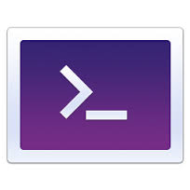
...and double-click it.

2. You will get a command-line shell. But you'll only ever need a few commands. First, open your TSCI-5050 folder and move anything in there you want to keep to a different location temporarily. Then delete it, like this:

rm -r TSCI-5050

Then clone a brand new copy of this repository.

git clone git@github.com:UTHSCSA-CIRD/TSCI-5050.git
cd TSCI-5050
git checkout YOURNAME

...but replace YOURNAME with the name of your GitHub account. You can stay in this branch for the rest of the semester.

The above steps will only need to be taken once for this class. After that, you only ever need to do the following:

3. Before beginning to work:

git merge --no-ff origin/master

4. From time to time while working:

git commit -a -m "this is a comment"

5. When you're done working for a while:

git push

That's it! Three commands from now on.

